VANE SHEAR TESTS
TORQUE WRENCHES
GENERAL
The Vane Shear Test was designed primarily to determine "in-place" shear
strength or consolidation potential of weak sensitive clays.
The structure of this type of material is so sensitive that it can be easily destroyed during the normal undisturbed sampling technique or may be destroyed during the shipping of the samples to a laboratory. Field testing of this weak type material may provide useful results if proper equipment is provided and correctly used. If the materials under test contain sand, gravel or saturated clays the test will not prove useful.
Generally speaking, the Vane Test can be helpful and useful in tests for low strength embankment foundations, structural foundations on soft plastic soils, landslides or slips in fine-grained soils, or for slope stability studies.
The result of the Vane Shear Tests are consistent with and somewhat higher than those obtained from samples in laboratory tests.
EQUIPMENT
The Acker Vane Shear Test Kits are designed for use with several combinations of pipe or casing and not limited to any particular type. As an example the Vane may be used in aluminum or plastic pipe as well as steel casing or steel pipes. There are two types of Acker Vane Shear Kits. One has a calibrated torque head, the other is equipped with two torque wrenches.
PROCEDURE
After the hole is bored or prepared, logged and conventional tests made, the depth may be selected for the Vane Shear Test. The hole may be from driving casing or auger boring. If the hole is augered to the test depth and remains open, the top of the hole should be collared with a short length of casing or pipe for mounting the Vane Test Assembly. Since the casing may not be in a tight hole it may have to be clamped or anchored. If mud is used to hold the hole - open it has been found to have a negligible effect upon the tests.

ASSEMBLY OF ACKER VANE EQUIPMENT
USING TORQUE WRENCHS
- Select proper vane and attach it to one 5 ft. length of drill rod. If 4" pipe casing is used, one may select the larger vane which is 3-5/8" across the diameter; this works very nicely inside the 4" ID pipe. Also note the 2-1/2" vane is the largest that may be used inside of 3" ID pipe and 2" inside 2-1/2" ID pipe.
- The selection of vane size also depends upon the type of materials under test. If the soil or clay is weak, the use of the larger vane is more desirable. Likewise if the material is stiffer, then the next or smaller size vane may be selected so that the test results will fall within the range of the vane being used.
- After the vane and first section of drill rod is lowered into the casing, attach a ball bearing guide coupling to the rod before the next rod is added. The guide coupling is used to keep the rods and vane in the center of the pipe. Guide collars are included in the kit to accommodate the guide couplings being used in all three sizes of casing or pipe. Note the guide collars are not designed to accommodate a tight fit as they are only centering guides. If and when the collars are used install them over the top of the guide bearing and secure, If installed on the bottom side they could loosen and fall down the hole. Guides should be spaced every 10 or 15 feet or divided up over the depth of the hole.
- After all the bearing guide couplings and collars are installed, and rod added to reach the top of the hole, the rods are held by a wrench or holding iron while the calibrated drive head is slipped over the rods and the casing. If the rod is not supported, the soft nature of the material at the bottom of the hole may allow the rods to sink before the rods are secured on the bearing guide. Place the thrust bearing in the bearing guide.
- Slip the collar over the AW drill rod 18 inches above the thrust bearing. With the drill rod centered, secure the rod using the four square head set screws. Screw the AW rod adapter onto the rod and attach the appropriate torque wrench. If the soil is weak, the 0-200 lb-in wrench may be adequate. For stiffer material the 0-600 lb-in wrench is recommended.
- Gently press (without rotating) the torque wrench, the rods and the vane into the undisturbed soil at the bottom of the hole. The collar will come to rest on top of the thrust bearing which will support the weight of the entire string of rods and allow for its free turning in the soil without sinking during the test.

- The test may now be started. Note the degree marks around the bearing guide. Mark a starting point on the collar with chalk or pencil and read off degrees from this point. Markings are in 30 degree increments. It is suggested that the turning of the torque wrench be constant until the test is completed. Do not stop and start or turn the wrench over to another operator during the test. Continuous turning of the wrench is most desirable for accurate results. The operator should use the same slow, steady rate when doing all tests.
- During the test operation, it is well to make note on the recording form, of the torque value reached or indicated on the wrench, as well as the degree to which the torque wrench has reached. .
- In some cases where the soils or clays have a high remolding strength the question of friction on the vane rod is brought up. Actual tests have proven the friction is negligible and is disregarded in 90% of the soils tested. However, a bladeless rod can be made up on special order when ordering the Acker Vane Kit to verify the tests.
- FOR REMOLDED STRENGTH TESTS - Following the determination of the maximum torque, rotate the vane with the wrench to free the vane. After a 5-minute rest period, the remolded test may be started as before. It is recommended that all tests be conducted in the presence of a soils engineer who may choose to dictate the timing and speed of the tests.
- As a supporting test, it is always prudent to obtain a sample from an adjacent hole at the same depth at which the vane test was made. This will provide some correlation between the actual sample and the vane shear test.
- Consult the Acker vane shear torque charts for instant reference on the vane constant of all three blade sizes.
- The remolded shear strength is very important and should always be determined as in highly compressible materials. It is also important in determining the sensitivity of a soil or clay. The initial shear strength divided by the remolded shear strength, is the "sensitivity". If the initial shear strength is 900 lbs. per square foot and the remolded strength is 300 lbs. per square foot, the sensitivity is 900 divided by 300, or 3.

COMPUTATIONS FOR TORQUE WRENCHES
- To convert torque (lb.-in.) to shear strength in pounds per square foot, please note the following:
*Vane constant as follows:
Acker — vane k = 5.17
Acker — 2-1/2" vane k = 2.50
Acker — 3-5/8" vane k = .905
*NOTE: Acker charts have converted lbs/sq. in. into lbs/sq. ft. values or constants. If the steps outlined are followed highly accurate results will be developed.
- FORMULA
Applied torque (lb.-in.) x vane constant = shear strength (lbs./sq. ft.)
Example:
600 lb.-in. x 5.17 (2" vane constant) = 3,102 lbsisq. ft. shear strength.
- FINAL
Testing laboratories report most results within 1% of vane shear tests. Many engineers prefer "in place" shear values over the laboratory test obtained from mishandled field samples. Where greater accuracy or an extended program warrants, the "Calibrated Drive Head" will provide the extreme accuracy desired.

PROJECT
DATE
FIELD VANE SHEAR TEST REPORT
(FOR USE WITH TORQUE WRENCHES)
TEST MO. • ELEV. TOP OF HOLE
BORING HOLE NO.
DEPTH TO TEST POINT
ELEV. TO TEST POINT
(TIP OF VANE)

LINE & STA. OFFSET

CHECK ONE -
VANE  DIAMETER | VANE  CONSTANT | WRENCH  USED
2"  2-1/2"  3-5/8" |  |  | 5.17  2.59 |  | 0-200  0-600
 |  |  | 0.905

ULTIMATE SHEAR STRENGTH (S) =VANE CONSTANT X APPLIED TORQUE (T)
(Les/SQ. FT.) (IN. — LBS.)

FRICTION ON VANE SHAFT |  | UNDISTURBED CONDITION |  | REMOLDED CONDITION
ROTATION (DEGREES) | TORQUE  READING(LBS—IN)(DEGREES) | ROTATION | TORQUE  READING(LBS—IN) | ROTATION  (DEGREES) |  | TORQUE  READING(LBS—INI
READINGS & CALCULATIONS |  |  |  |  | UNDISTURBED CONDITION |  | REMOLDED CONDITION
MAXIMUM TORQUE. READING FOR VANE (LBS—IN) A
MAXIMUM TORQUE READING FOR SHAFT (LBS—IN) B
NET TORQUE (A-8 )
ULTIMATE SHEAR STRENGTH (S) = VANE CONSTANT X TORQUE

SHEAR STRENGTH (UNDISTURBED)=
^{SENSIVI}TY ⁼ SHEAR STRENGTH (REMOLDED)
NATURAL WATER HALF—UNCONFINED COMPREHENSIVE
CONTENT % • STRENGTH LBS/SQ. FT.

TECHNICIAN | CHECKED

TORQUE. CHARTS FOR VANE SHEAR TESTING

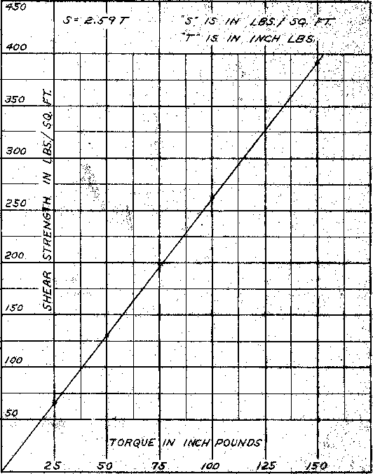
I: I
"S" IS /N LBS./ SQ. Al:"
/s IN /NCH LBS
400
350 1.₄.
300 co
•
•
250
200 co
/00
TORQUE IN /NCH POUND.S⁻
5 50 75 /00 /25 /50
2
450
 |  | 5•6./ | IIII | 7 | r |  |  | .S"  "77 | /5 /S | !I'll'  IN IN |  | /NCH | LBS./S¢. | LBS. | III  Pr
/400
0
0
SHEAR ,STriTAGH L.4,5:/‘-5;4¹, FT
/50
 | zs |  |  | so |  |  | rOfrOUE  76  IN  loo |  |  | /NCH |  |  | /zs  POUNDS |  |  | /so

This torque chart is for use with the 2" O.D. vane.
Note: The 2" O.D. vane is for use in VA" casing.
This torque chart is for use with the 2¹/₂" van:. Note: The 2¹/₂" O.D. vane is for use in 3" casing.

This torque chart is #or use with the 3³/₄" O.D. vane. Note: The Mit" 0.D.'irane is for use in 4" casing.
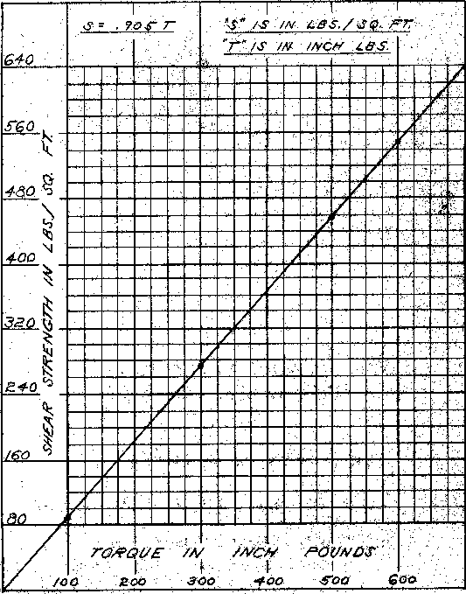
/0
TORQUE /4/ /A/C;,/ ROe/NOJ⁻o Roo 300 400 .6⁻00 6'00
3—€0
480 .q
(,)
4.00^{\1}
320
240 ^{c}'³
/60 ^{c)}
80
I I
",s" iN 48.5./ F⁻77
7⁻ IS IN /NCH Les
640
.S • 903⁻7—
Page 3

